A .Interim Report Form
For Research Projects Funded through the
National Science, Technology and Innovation Plan (NSTIP)
1. PROJECT INFORMATION
Project Code
Project Title
Principal Investigator
Institution
Strategic Technology Area
Project Period (Starting Month/Year – Ending Month/Year)
Reporting Period (Starting Month/Year – Ending Month/Year)
Project Budget (SR)
Project Summary (max. 300 words)
Briefly describe the importance of the research project, and how it supports the goals of the NSTIP in the identified strategic technology area. In addition, please summarize progress and plans for the second year of the grant.

2. PROJECT PROGRESS
Describe the objectives, phases, and tasks outlined in the original proposal and indicate the status of each task. This information can be inserted from Form RE-D1-3 of the original proposal, as long as the information contained therein was comprehensive. Otherwise, pertinent information from the original proposal can be entered in the table below (limit table to one page).
Objectives | Phases | Tasks | Status (Completed, Ongoing, Planned, Modified *, Discontinued*) | Percentage of achievement
(*) Give details below if modified or discontinued.

Describe in 1,000 words or less:
- Progress made toward achieving the above objectives, including a description of results obtained thus far;
- Challenges encountered while trying to accomplish the tasks (for example, delays in obtaining equipment, turnover in personnel, or recent scientific discoveries that affected your research program) and how you overcame them;
- Implemented changes to the original objectives, tasks, materials, resources or timeline;
- What do you plan to do during the next reporting period to accomplish the objectives (either original or modified)?

3. PERSONNEL INVOLVEMENT
Provide details addressing the contributions of each person in accomplishing the project tasks/objectives during the reporting period. Include personnel involved that are not supported by NSTIP award.
Team Members | Name | Contribution
Investigator
Co-investigator/s
Consultant/s
Student/s (specify undergraduate, M.S. or Ph.D.)
Research Staff (e.g., Postdoctoral Associate, Technician, Manager)
Administrative Staff
Others (provide title and role)
Describe any changes in personnel and/or their roles from the original proposal. Please also include individuals not included in your original proposal that provided significant contribution to the project to date. (max. 150 words)

4. RESEARCH OUTPUTS
Include information in the following categories that directly relates to your NSTIP-funded project. Include details, status (e.g., accepted, published, submitted, under preparation), and dates for each category that applies to your project.
OUTPUTS:
Patents: (List details on a separate sheet) | Quantity | Status | Date
Patent applications
Patent registrations
Licenses
Other research commercialization activities
Publications: (List on a separate sheet, the details of the publication, e.g., title, journal, impact factor with source such as Thomson Reuters ISI) | Quantity | Status | Date
Refereed publications
Non-refereed publications such as journal articles, reviews, conference papers, books and book chapters
Presentations | Quantity | Status | Date
State the quantity and list & specify on a separate sheet whether they were conference talks, seminars, lectures, invited talks, etc., and whether they were institutional, regional, national or international.

Technical Outputs | Quantity | Status | Date
List below any technical outputs such as CDs, software programs, databases, algorithms, and measurement instruments.

Service to the Research Community | Quantity | Status | Date
List any membership on national and international science committees, advisory boards, journal editorial boards, conference organizing committees, etc.

Impact on Policy | Quantity | Status | Date
List any contributions to development of research or clinical guidelines, review protocols, indicators, membership on government advisory committees, commissioned governmental agencies, meetings with policy makers, etc.

Awards and Honors | Quantity | Status | Date
List any major awards, indicating their scale—regional, national, international—and honors such as academic chairs and endowed positions.

Other | Quantity | Status | Date
List any other forms of research dissemination that is intended for non-scientific audiences (such as radio talks, newspaper articles, television appearances).

5. BROADER IMPACTS OF THE PROJECT
Include information in the following categories that directly relates to your NSTIP-funded project. Include details and dates for each category that applies to your project.
Teaching and Training
Describe courses, classes, and workshops that were developed, and your role in the activity (for example, teacher, organizer, developer).

Infrastructure
If you purchased equipment, describe how it adds to the capability of the institution and training of researchers outside the project. Indicate whether this equipment is available elsewhere in the institution and why its purchase was necessary for this project.

Collaborations
Describe the institution, disciplinary focus, research expertise, and nature of any new or unforeseen partnerships that were developed during the project.

Funding
Describe how this research has led to additional funding or prospects for future funding awards and contracts for project investigators, students and staff. Please list the applications, dates, reference numbers, and amount awarded, if applicable.

Others
Describe the benefits of your research to society that are not covered by the categories above.

6. BUDGET
Category | First year |  | Second year
 | Amount Awarded | Amount Expended | Amount Awarded | Amount Expended
Principal Investigator
Co-Investigator/s
Consultant/s
Student/s (specify undergraduate, M.S., Ph.D.)
Research Staff (specify Postdoctoral Associate, Technician, Manager)
Administrative Staff
Major equipment (list items >100,000 SR below)
Other Equipment (list items >10,000 SR below)
Materials & Supplies
Travel (e.g., training, conference, field trips)
Dissemination (e.g., publications, patents, workshops, public outreach)
Other (specify any >1,000 SR)
Total
Please list equipment (>10,000 SR) purchased. In addition, provide brief descriptions of travel, dissemination, and other expenditures during the reporting period. If funding sources other than NSTIP have supported any aspect of the research program, please describe the funding amount and nature of support (financial, in-kind, facilities, etc.) Also, comment on any existing core or shared research facilities that you have used for the project to date. If category expenditures differ from budgeted amounts by more than 10%, please comment. (max. 150 words)

7. Describe any other concerns and comments related to the interim progress of the research project that were not covered in the sections above (max. 250 words).

Thanks

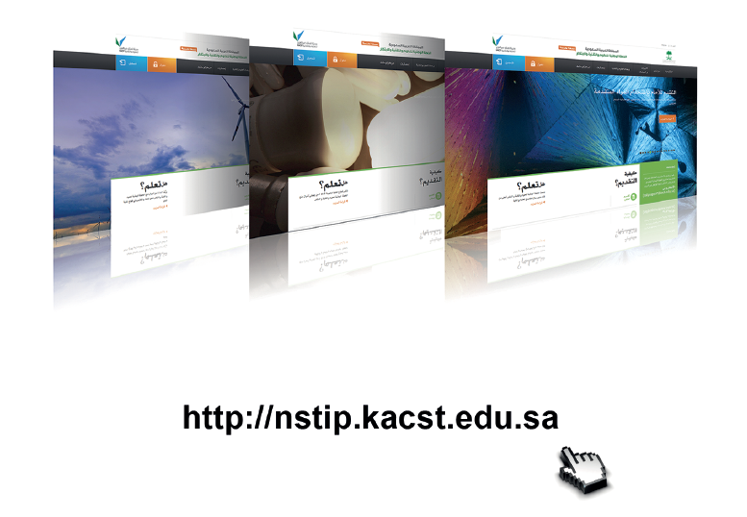

MAARIFAH@kacst.edu.sa

